SEMESTER ONE EXAMINATION 2011
Stage 3a Applied Information Technology
SOLUTIONS
TIME ALLOWED FOR THIS PAPER
Reading Time: Ten Minutes
Working Time for Paper Three Hours

MATERIALS REQUIRED/RECOMMENDED FOR THIS PAPER
TO BE PROVIDED BY THE SUPERVISOR
This Question Booklet to include your answers
TO BE PROVIDED BY THE CANDIDATE
Standard Items: pens, pencils, crayons, eraser or correction fluid/tape, ruler
Special Items: calculator satisfying the conditions set by the Curriculum Council

IMPORTANT NOTE TO CANDIDATES
No other items may be taken into examination room.
It is your responsibility to ensure that you do not have any unauthorised notes or other items of a non-personal nature in the examinations room. If you have any unauthorised material with you, hand it to the supervisor BEFORE reading any further.

INSTRUCTIONS TO STUDENTS
Write all answers in pen
Allowed pens, eraser, correction fluid/tape, and ruler.
This paper is in four (4) sections.

SECTION 1: Multiple Choice. Attempt ALL questions
(20 questions = 20 marks)
Indicate your answer on this answer sheet.

SECTION 2: Short Answers. SIX (6) questions.....
EACH MUST BE ATTEMPTED. NO CHOICE.
(6 questions = 30 marks)
Write your answer on this answer sheet.
SECTION 3: Extended Answers.
Extended Answer TWO (2) questions.
(2 questions = 50 marks).
Write your answer on this answer sheet.

SECTION 4: Production Answers.
Production questions.
( questions = 100 marks).
Write your answer on this answer sheet.

YOU MUST WRITE ON THIS PAPER

Question Answer

Multiple Choice Answer Box
(answer a, b, c or d)
1 | A | 11 | A
2 | D | 12 | B
3 | B | 13 | B
4 | C | 14 | D
5 | A | 15 | A
6 | D | 16 | B
7 | C | 17 | B
8 | C | 18 | C
9 | C | 19 | D
10 | C | 20 | B
Total

1 a  2 d  3 b  4 c  5 a  6 d  7 c  8 c  9 c  10 c | 11 a  12 b  13 b  14 d  15 a  16 b  17 b  18 c  19 d  20 b

- The phrase ‘green computing’ most commonly refers to
- Energy –efficient enabled computers.
- Sharing of resources between computer systems.
- Making local CPU resources available for networked projects.
- Reusing software scrap for future projects.

- What is an author required to do in order to assert copyright on their intellectual property?
- Include their name on the work.
- Register their work with the government.
- Retain possession of the original copy of the work.
- Nothing: copyright is assigned automatically.

- The main difference between a tablet computer and a netbook is that the tablet computer has
- A colour screen.
- A touch screen.
- No internal hard drive.
- No built-in networking facilities.

- The process of ‘defragmentation’ of a hard drive involves the
- Removing unwanted files to increase the amount of free space.
- Backing up files to reorganise them logically.
- Moving files to make existing files and free space contiguous.
- Creating new directories to make existing files easier to access.

- A new version of software is said to be ‘backwards compatible’ if
- It can read data files created using previous versions.
- It can read data files in either previous or future versions.
- Data files created can be read using previous versions.
- Data files created can be read in either previous or future versions.

- Software that is provided for use, modification, and redistribution is called

- Shareware
- Freeware
- Custom software
- Open Source Software

- A ‘firewall’ is security software that inspects and controls network traffic

- Into a computer.
- Out of a computer.
- In both directions.
- In neither directions.

- Which design principle is illustrated by the following pictures?

- Balance.
- Emphasis.
- Proportion.
- Harmony.

- Downloading movies and music without permission violates laws related to

- Equity.
- Intellectual property.
- Copyright.
- Fair use or fair dealing.

- ‘requirements analysis’ involves determining what

- Physical resources will be needed for a project.
- Human resources will be needed for a project.
- Features the client expects from a system.
- Facilities the system needs in order to perform its tasks.

- The principal feature of a web page that uses push technology in that the
- Client doesn’t initiate the transfer of information.
- Server doesn’t contain all of the necessary information.
- Information is transferred via a number of different channels
- Information is encrypted at the server rather than at the client

- ‘Technological convergence’ is best understood as different
- Industries evolving to use similar approaches.
- Technologies evolving to perform similar tasks.
- Tasks evolving to use similar technologies
- Professions evolving to employ similar methods.

- Which of the following network topologies uses a ‘control token’?
- Tree network
- Ring network
- Mesh network
- Star network

- The principal difference between the HTTP and HTTPS protocols is that
- HTTP can transfer larger files.
- HTTPS can transfer files faster.
- HTTP can transfer more file types.
- HTTPS can transfer files more securely.

- Which one of the following applications would be used in ‘desktop publishing’?
- Adobe Acrobat Reader.
- Three panel brochure.
- A text book on desktop publishing.
- Web page.

- How many frames per second are generally required to achieve real-time computer animation?
- 6
- 60
- 600
- 6, 000

- A NIC (Network Interface Card) enables a computer to
- Establish virtual links between your computer and any peripheral.
- Establish a link to networked peripherals.
- Establish a link directly to the internet.
- All of the above.

- A student wants to choose a storage format for a photo story she has produced which has a file size of 900 000 kilo bytes. Which would be the most suitable storage medium?

- Floppy Disk (1.44 MB)
- CD-RW (800 MB)
- DVD-R (4.7 GB)
- USB (Flash or Thumb) Drive (256 MB)

- The best way without cabling, to network computers throughout your home is through:

- a DSL modem.
- an ISDN modem.
- a network card.
- a wireless router.

- When using a lossless compression, the compression and un-compression of a file results in a file that is
- Smaller in size than the original file.
- The same size as the original file.
- 10 K larger in size to the original file.
- Larger in size than the original file.

End of Section One

Section Two: Short answer 15% (30 Marks)
This section has six (6) questions. Answer all questions.
Write your answers in the space provided.
Spare pages are included at the end of this booklet. They can be used for planning your responses and/or as additional space if required to continue an answer.
- Planning: If you use the spare pages for planning, indicate this clearly at the top of the page.
- Continuing an answer: IF you need to use the space to continue an answer, indicate in the original answer space where the answer is continue, i.e. give the page number. Fill in the number of question(s) that you are continuing to answer at the top of the page.
Suggested working time: 20 Minutes

Question 21 (4 marks)
Outline four ways in which the effective use of ICT can increase the productivity of manufacturing industries.
Answer:
(Automatic Shutoff) Increasing safety by leaving automatic shutoff on systems also allows editing needs for people to monitor systems.

(Automated process ) Automated process take less time and can be done thousands of times without user input and at a lower cost than having an employee do this.

(Computer on at night) ICT Systems can work through the night and do not need workers or employees therefore increasing productivity.

(Auto Repair) ICT Systems can automatically find inefficient areas of the production process so that they can be rectified.

(Clear support is given for descriptions that would increase productivity of manufacturing industries) = 4 out of 4

One mark for each valid response to a maximum of 4 marks
- Automation - It reduces costs by increasing the capability of machinery, thus reducing the
need for human input.
- It increases flexibility in production planning and scheduling, reducing lead
times and improving responsiveness to customer needs.
- It facilitates accurate and fast modelling of industrial processes, enabling
their optimisation in various ways. Responsive
4. It improves communication between team members, record-keeping, etc.
5. Rapid prototyping and modelling
6. Access global markets for sales, accessing resources and research

Marker’s notes for other possible answers:
Question 22 (5 marks)
- Define ‘inclusivity’ as it applies to the design of an ICT product or service. (1 mark)
One mark for a clear definition
Inclusivity in design means ensuring that a product or system is accessible to as
many (wide range) users as possible. = 1/1
- A design needs to be made inclusive of an ageing population. Identify four barriers to inclusivity and outline their solutions. (4 marks)

One mark for each valid response to a maximum of 4 marks
- Compensate for failing eyesight, e.g. by providing a zoom facility.
Make things bigger and easier to see

2. Compensate for failing hearing, e.g. by providing visual alternatives to sound. Enable screen narration – speaks to customer

3. Compensate for failing dexterity, e.g. by providing large buttons/icons to click
on. Big buttons easier to use

- Compensate for failing memory, e.g. by storing relevant important data.
Automatic File savers

5. Compensate for failing mobility, e.g. by providing remote control facilities.
Ability to slow down process i.e. Slow mouse tracking

Marker’s notes for other possible answers:
Question 23 (6 marks)
- Describe four aspects of an ICT project that need to be monitored and documented over the course of its development.
(4 marks)
One mark for each type of information with a valid justification to a
maximum of 4 marks
- Project spending, to check that the budget is not exceeded
Cost – needs to be estimated and stick to budget.
- Client expectations, to check if design changes are needed.
Time taken – time costs money
- Personnel situation, to ensure that the required skills and manpower is available.
Human resources – employ the right people for the job
- Provision of hardware and software, to ensure that the goals are achievable.
Correct equipment for tasks being proposed
- Timelines , to ensure that they are being met or progress made.
Project Management – someone keeps staff on task

Marker’s notes for other possible answers:
- Define ‘top-down’ as a project management strategy.
(1 mark)
One mark each for a clear explanation
A top-down project starts with a high-level specification of the system being
built, and iteratively refines this specification until all parts of the specification
can be implemented directly.
Answer: Starts with the whole project in mind then developing the smaller sub sections and tasks
- Define ‘bottom-up’ as a project management strategy.
(1 mark)
One mark each for a clear explanation
A bottom-up project starts by implementing a range of low-level facilities and then iteratively building larger sub-systems using these facilities, until finally the entire system can be assembled

Answer: Starting with the smaller parts or tasks of the project and piecing them together to form the whole project.

Question 24 (2 marks)
Describe briefly the type of network traffic the following protocols control.
- HTTP (1 mark)
HTTP controls, establish connection, allows web page traffic or Hyper text
Controls traffic between websites and computer – (directs upload and downloads)
Note to markers: No mark for correct expansion of the acronym

- SMTP (1 mark)
SMTP controls email or small messaging
Simple Mail Transfer Protocol controls the electronic messaging or e-mail network traffic that clients receive through e-mail application such as Microsoft Outlook – Eudora , My Mail etc.
Note to markers: No mark for correct expansion of the acronym

Question 25 (11 marks)
You wish to outsource the purchasing of a number of computers.
- List four criteria you would use to select a company to supply the computers.
(4 marks)
One mark per valid criteria to a maximum of 4 marks
- Cost
- Machine performance against industry benchmarks
- TCO – Total Cost of Ownership
- Vendor history
- Vendor ability to support equipment
- Reliability of equipment
- Reputation of vendor and equipment
- Added services
- Management
- Training
- To minimize the cost you consider reusing old computer components and peripherals in or with your new computers. Describe, with a suitable example, two problems that may be encountered.
(4 marks)
One mark for a valid issue and one mark for an example of the issue to a maximum of 4 marks
- Compatibility of old hardware with new hardware – graphics cards
- won’t fit new slots.
- Compatibility of old software with new operating systems – 64bit vs
- 32 bit
- No drivers for old peripherals.
- No plugs / IO ports for equipment such as no LPT ports on new
- hardware for printers.

- A company does not have an IT support department. Describe three ways in which it could support its staff that use computers.
(3 marks)

One mark for a valid answer to a maximum of 3 marks – accept list
- Forums
- Bulletin boards
- On-line tutorials
- Live chats
- Support through a local

Question 26 (2 marks)
A large international company has imposed a ban on accessing social networking sites from its computer networks. The employees would like to have this ban lifted.
List and justify two benefits that the company could gain from allowing its staff to access social networking sites.
One mark for each benefit with a valid justification to a maximum of 2
marks
- Forums to get information
- Collaborate with others at school/work or around the world.
- Share work or problems with others
- Create interest groups – chess club, rocket clubs etc.

End of Section Two

Section Three: Extended answer 25% (50 Marks)
This section has two (2) questions. You must answer both questions.
Write your answers in the space provided.
Spare pages are included at the end of this booklet. They can be used for planning your responses and/or as additional space if required to continue an answer.
- Planning: If you use the spare pages for planning, indicate this clearly at the top of the page.
- Continuing an answer: IF you need to use the space to continue an answer, indicate in the original answer space where the answer is continue, i.e. give the page number. Fill in the number of question(s) that you are continuing to answer at the top of the page.
Suggested working time: 50 Minutes

Question 27 (25 marks)
Firefly Fine Dining is an international restaurant chain. It has restaurants situated in almost every continent and in smaller nations located in the Caribbean Sea and The Pacific and Indian Oceans. Each restaurant has been positioned in popular tourist areas. The management of Firefly wants all transactions conducted at the restaurants sent to its central database at the close of each restaurants business day. In addition, the management wants each restaurant to send all of its data files (which record sales, customer information, employee timesheets, payments made and supplies ordered) to its head office in Perth to be stored on the company’s server.
- All files from each location must be sent across the internet. Describe what the company could do to reduce the cost and time taken to transmit each file. (4 marks)
Cost: Time:
Excellent (4) Describes a way in which the cost and the time taken to transmit data files across the internet are reduced (see notes below for possible reasons).

Markers Notes:
- Zip / Compressed files
- File formats, csv / xlsx, text, rtf, doc
- Time – off peak
- Network / Internet / Server speeds
- Incremental backup.
- Automation
4 marks

Good (3) Outlines briefly a way in which the cost and the time taken to transmit data files across the internet could be reduced.
3 marks

Acceptable (2) Makes generalised comments that suggest a way in which the cost and the
time taken to transmit data files across the internet could be reduced.

or

Describes a way in which the cost or the time taken to transmit data files
across the internet is reduced (see notes below for possible reasons).
2 marks
Limited (1) Outlines briefly a way in which the cost or the time taken to transmit data files across the internet could be reduced.
1 mark

- The company’s head office wants to conduct a video conference meeting with all of its managers at the same time. Discuss four issues that would affect the success of the conference and suggest alternative methods that would address these issues.
(8 marks)
One mark for each valid issue and one mark for an alternative, to a
maximum of 8 marks
- Time delays between sites – do a number of conferences depending on continent.
- Language barriers – interpreters
- Bandwidth issues, some using satellites causing lag or inability to carry signal. Use phones in low bandwidth areas
- Software not the same.
- Setting up computers to do the conference
- Establishing video conference equipment
- Time zones
- Cultural – language, accents

- Some of the information that is sent from various locations around the world to the head office is confidential. Explain four methods that would ensure the security and integrity of data on a PC before it was sent.
(8 marks)
Two marks per valid issue with an explanation, 1 mark just for issues with no explanation. Maximum 8 marks.
- Encrypt data before being sent to deny access
- Passwords used on PC ends to prevent access
- Secure PCs away from customer access
- Firewalls on PC to stop access
- Anti-malware on PCs to prevent access
- Virus protection
- Levels of access or authorisation

- The data collected at the head office is stored in a data warehouse. Explain what a data warehouse is and list three ways in which the management could use the data to benefit the company.
(5 marks)
Two marks for a valid data warehouse explanation and 1 per use, to a maximum of 5 marks.
A collection of data, from a variety of sources, organized to provide useful guidance to an organization's decision makers.

Uses
- Decision making process
- Show trends in business
- Indicate what is popular, what is not.
- Cost trends
- What is profitable, what is not
- Historical

Question 28 (25 marks)
Nimble Office has recently conducted an internal review of its employees and discovered that some employees have a basic knowledge of the use of ICT. You have been asked to advise Nimble Office on how to improve these employees’ knowledge of and skills in processing and managing typical office data, such as text documents and spreadsheets.
To advise Nimble Office on this issue, you must address the following:
Outline three criteria that can be used to determine competent use of standard office applications. (6 marks)

Lists three criteria 3 marks
Lists two criteria 2
Lists one criteria 1
List no or incorrect criteria 0

3 marks
Outline three criteria that can be used to determine competent use of standard office applications

- speed, accuracy,
- formatting,
- presentations,
- printing,storage,
- transferring etc.

2 Marks
Outlines how each criterion can be used to determine effectively employees’ competent use of standard office applications.

Outlines how each criterion can be used to determine employees’ competent use of standard office applications.

1 Mark
Presents generalised and superficial comments on how each criterion may assist in determining employees’ skills and/or knowledge

- Develop a methodology for assessing the extent to which employees meet these three criteria. (6 marks)
6 Marks Develops a pertinent methodology that indicates what and how evidence is to be collected in order to provide a realistic and workable assessment of the three competencies.
- workflow
- application, time
- sheets, sampling,
- self appraisal

5 Marks Develops a methodology that indicates what and how evidence is to be collected in order to provide a workable assessment of the three competencies.

4 Marks Develops a methodology that engages with the three competencies and makes comments of how and what evidence is needed to be assessed.

3 Marks Provides a methodology that outlines in general terms how and what evidence is needed to be assessed. Provides a basic methodology that outlines in general terms
how or what evidence is needed to be assessed.

2 Marks Outlines in general terms how or what evidence is needed to be assessed. Does not indicate what competencies are being assessed.

1 Mark Lists a way of assessment with no supporting comments.
- Describe four strategies for improving the knowledge of and skills in processing and managing typical office data. (8 marks)
- training, courses,
- online, mentor, $s,
- promotion
- incentives
7 – 8 Marks Provides insightful descriptions of tailoring each strategy for the specific purpose of improving the management of typical office data.

6 Marks Provides detailed descriptions of how each strategy considers the purpose of improving the management of typical office data.
4 – 5 Marks
Provides descriptions of how most strategies address the purpose of improving the management of typical office data.

2-3 Marks Up to four strategies are given. Provides general comments on how to improve the knowledge and skills of standard office applications with some consideration for how to manage typical office data.

1 Mark Provides generalised and superficial comments on how to improve the knowledge and skills of standard office applications with limited consideration for how to manage typical office data.
Lists strategies with limited comments for support.
- If the company were to implement a new ‘employee information system’, recommend and justify two features that should be included to help it manage all employees’ knowledge and skills while accommodating the rapid changes in ICT.
…recommend and justify two features that should be included to help it manage all employees’ knowledge and skills while accommodating for the rapid change in ICT.

- In work training,
- attending courses,
- online worksheets,
- mentors,
- money incentives $s,
- promotion incentives
(5 marks)
5 Marks Recommends two features. Provides pertinent and insightful justifications as to how the recommendations are intended to assist management in tracking employees’ skills and identify ongoing training needs.

4 Marks Recommends two features, with well-considered justification as to how the recommendations are intended to assist management in tracking employees’ skills and identify ongoing training needs.

3 Marks Recommends two features, with justification as to how the recommendations are intended to assist management in tracking employees’ skills and identify ongoing training needs.

2 Marks Up to two recommendations provided with generalised comments as support.

1 Mark Up to two recommendations provided with limited support.

Section Four: Production 50% (100 Marks)
There is one question in this section. You must answer all parts of the question.
Spare pages are included at the end of this booklet. They can be used for planning your responses and/or as additional space if required to continue an answer.
- Planning: If you use the spare pages for planning, indicate this clearly at the top of the page.
- Continuing an answer: IF you need to use the space to continue an answer, indicate in the original answer space where the answer is continue, i.e. give the page number. Fill in the number of question(s) that you are continuing to answer at the top of the page.
Suggested working time: 75 Minutes

Question 29
A company called AnyTime-AnyWhere Network Solutions is an Internet Service Provider (ISP).
AnyTime-AnyWhere has a website that allows potential and existing customers to browse its products and services. The website also has a variety of features for its customers. Existing customers can log in and access the status of their internet accounts as well as access chat rooms where they can discuss various issues and topics.
AnyTime-AnyWhere wishes to increase its access to a new market audience that includes users of mobile technologies such as web enabled mobile phones, PDAs and other mobile internet capable devices. To do this AnyTime-AnyWhere wants to create a website that can be viewed on and suit the design features of mobile devices. The website will be called the mobile website.
Your task is to develop a mobile website for AnyTime-AnyWhere to be viewed on mobile devices.

An example of a mobile device is provided below. It has a display that is 3.5 inches (8.9cm) diagonally and 480 x 320 pixel resolution at 163 ppi.
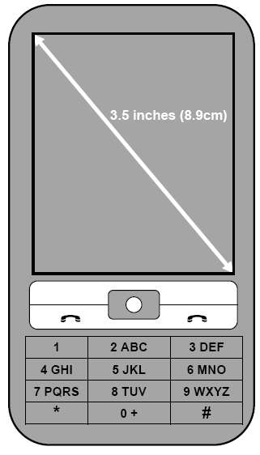

In order to develop a mobile website, you will need to complete four parts of the task. An overview of this process is outlined below:
Part 1: Pre-design (30 marks)
Identify trends in mobile computing.
Analyse the design of a website and mobile website.

Part 2: Design
Explore how to meet AnyTime-AnyWhere’s design criteria.
Design a mobile website.

(28 marks)
Part 3: Analysis
Justify how your design meets the requirements
(30 marks)
Part 4: Modification of design
Modify your design of a mobile website so that it is inclusive of older users.
(12 marks)

Part 1: Pre-design (30 marks)
- In preparation for designing AnyTime-Anywhere’s mobile website, identify five emerging ICT trends, outlining briefly how they will inform your design.
(5 marks)
Notes: Candidates may refer to the following trends in their responses:
- Simplicity of page layout
- Use of white space on a small screen
- No images
- Prioritising content
- Minimal text entry
- Use of drop-down menus to save space
- Html5
- CSS3
- Flash enabled browsers
- Standards compliance
- Interfaces
- Dominance of iPhone like interfaces
- Location services gps
- Web 2.0
- Social networks

5 Marks Identifies five emerging ICT trends and outlines how each is relevant in informing a design for a mobile device.
or
Lists five emerging ICT trends

4 Marks Identifies four emerging ICT trends and outlines how each is relevant in informing a design for a mobile device.
or
Lists four emerging ICT trends

3 Marks Identifies three emerging ICT trends and outlines how each is relevant in informing a design for a mobile device.

2 Marks Identifies two emerging ICT trends and outlines how each is relevant in informing a design for a mobile device.

1 Mark Lists one emerging ICT trends

- Discuss two issues relating to social implications and trends raised in the article ‘Paypal brings m-commerce to Australia’ below.
PayPal brings m-commerce to Australia
PayPal has added mobile commerce (m-commerce) to its range of services offered to Australian mobile phone users, which the launch of PayPal Mobile Checkout.
The service offers consumers the opportunity to make instant and secure payments to businesses through a mobile phone.
When using the service, customers can access sites designed for mobile devices on their mobile phone and purchase products and services using their PayPal account.
Not all mobile phones will be able to access mobile websites and purchase products and services, only users with “smart phones” that have secure payment functionality built into their operating systems will be able to participate.

1 mark for each simplistic but valid discussed point with an extra 1 mark for a more detailed discussion, to a maximum of 4 marks
Possible responses:
1. Cater for impulse buyers
2. Security of personal information, identity theft
3. Theft of mobile phones more likely
4. Cashless society, good or bad?
5. Will all adults now need a smart mobile phone and a PayPal account?
6. Access to technology
7. Inclusivity
8. Digital divide
9. Fraudulent sales

To assist you in developing the mobile website AnyTime-AnyWhere has provided an example of a website (Stimulus A) and a mobile website (Stimulus B) from a competitor’s site.
- Identify (by circling and naming) five design features for the website
Stimulus A: website
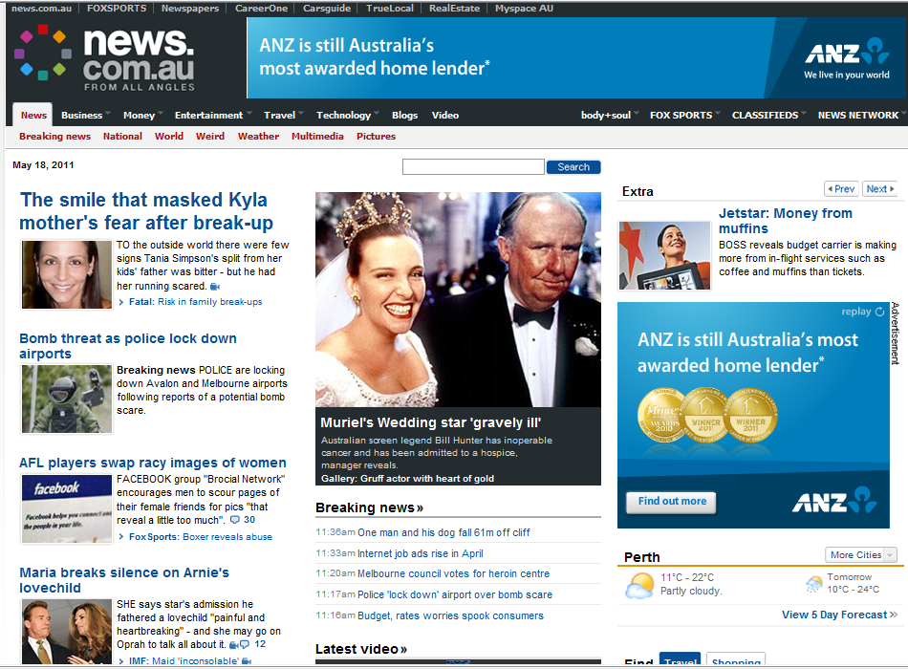
(The bottom part of this webpage is not shown here)
Identifies correctly 5 design features 5 marks
Identifies correctly 4 design features 4
Identifies correctly 3 design features 3
Identifies correctly 2 design features 2
Identifies correctly 1 design features 1
Identifies correctly 0 design feature 0
Total 5

- Identify (by circling and naming) five design features for the mobile website.
Stimulus B: mobile website
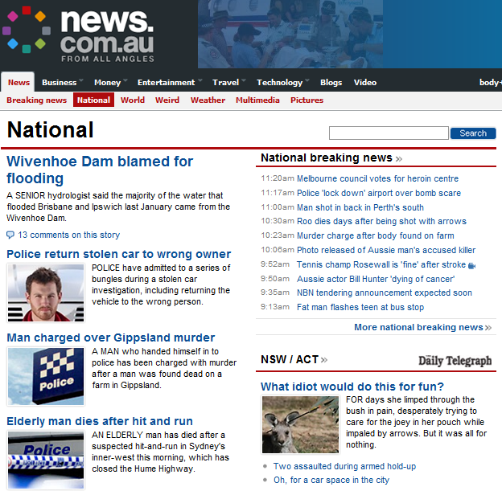
(The bottom part of this webpage is not shown here)

- use of drop down menus – saves space
- targeted information, different on mobile web site
- less advertising
- use of contrasting colours
- minimal navigation options

- Compare the stimulus materials A and B and explain why certain design features are used to suit the specific viewing requirements of a website and a mobile website. Refer to four of the design features identified in part (c) to support your response.
(16 marks)
What feature 1 mark per repeated feature in the web and mobile site
Compare 2 marks per feature compared with a detailed comparison
Why 1 mark for identifying why that feature was applied, linking the restrictions associated with the hardware and software.

Part 2: Pre-design (28 marks)
- AnyTime-AnyWhere has given you five design criteria that it wants incorporated into its mobile website. Justify briefly one way in which you could meet each of the criteria listed below in your design for a mobile website.
AnyTime-AnyWhere design criteria:

1 | Meet user needs quickly | (2 marks)
2 | Distinguish clearly selected items | (2 marks)
3 | Make user input as simple as possible | (2 marks)
4 | Display only essential information | (2 marks)
5 | Design manageable page layouts for users of a mobile device | (2 marks)

Description | Mark
1. meet user needs quickly | Lists one way 1  Justifies implementation 1
2. distinguish clearly selected  items | Lists one way 1  Justifies implementation 1
3. make user input as simple as possible | Lists one way 1  Justifies implementation 1
4 display only essential  information. | Lists one way 1  Justifies implementation 1
5. design suitable page  layouts for a mobile device | Lists one way 1  Justifies implementation 1
TOTAL 10

Possible responses:
1. Provide search feature, drop down lists, Tabs
2. Font and or colour change, background highlight
3. Use of drop down menus, use of predictive text, multiple screens, voice activation
4. Show headings, intro sentences, links to expanded documents or related articles
5. Auto reformat for portrait or landscape viewing on most common smallest screen size

One long column or swipe screen
Multiple expanding / collapsible headings
Below is a snapshot taken from AnyTime-AnyWhere’s website. Design a sample mobile website using some or all of the content presented in the snapshot.
In your design you must:

- incorporate AnyTime-AnyWhere’s design criteria | (5 marks)
- address one emerging ICT trend (identified in Part 1) | (2 marks)
- address one social trend (identified in Part 1) | (2 marks)
- select design features for a mobile device (identified in Part 1(c)) | (5 marks)
- use an appropriate design methodology to manage your ideas (e.g. clear sketches, dimensions, annotations, sequencing of work, checklists, etc.) | (4 marks)

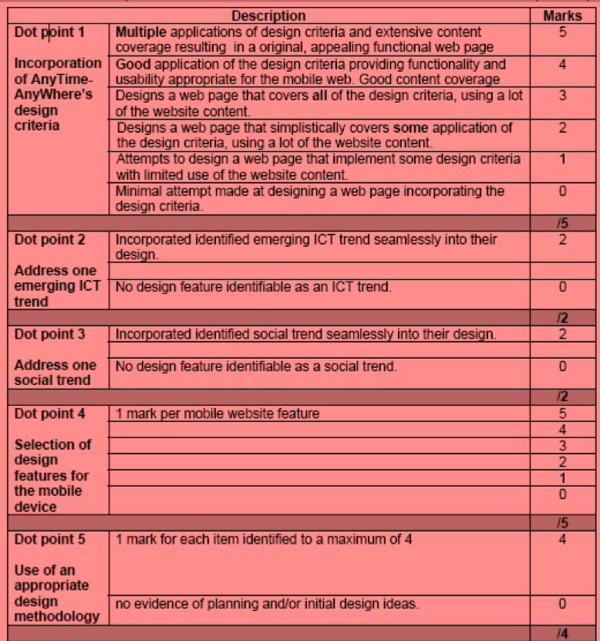

Part 3: Analysis (30 marks)

(a) Justify how your mobile website design addresses the design criteria and how your
selection of three design features suits the viewing requirements for a mobile website.

(25 marks)

AnyTime-AnyWhere’s design criteria

1. Meet user needs quickly
2. Distinguish clearly selected items
3. Make user input as simple as possible
4. Display only essential information
5. Design manageable page layouts for users of a mobile device.
Design Features Justification of the selection of three design features for the purpose of meeting the viewing requirements of a mobile website.

5 Marks Presents insightful and appropriate justification detailing how three pertinent design
features were considered for the purpose of suiting a mobile website.

4 Marks Provides appropriate justification detailing how three pertinent design features were
considered for the purpose of suiting a mobile website.
Provides some justification explaining how three design features were considered for the
purpose of suiting a mobile website.

3 Marks Provides an explanation discussing how three design features were considered for a mobile
website, at least two features meet the purpose or provides appropriate justification
detailing how two pertinent design features were considered for the purpose of suiting a
mobile website.

2 Marks Provides comments on three design features generalising the purpose of selection for a mobile website or provides some justification explaining how two design features were
considered for the purpose of suiting a mobile website.

1 Mark Provides superficial comments on three design features generalising the purpose of
selection for a mobile website or provides appropriate justification detailing how one design
feature was considered for the purpose of suiting a mobile website.

Provides limited indication for how the purpose of selecting design features for a mobile
website were considered.

Meet user needs quickly

4 or 5 Marks
Presents insightful and appropriate justification detailing the way/s in which this criterion is
addressed.
3 or 4 Marks
Provides appropriate justification outlining the way/s in which this criterion is addressed.
1 or 2 Marks
Provides some justification outlining the way/s in which this criterion is addressed.1 or 2
0 Marks
Presents superficial references to this criterion
Distinguish clearly selected items

4 Marks Presents insightful and appropriate justification detailing the way/s in which this criterion is addressed.

3 Marks Provides appropriate justification outlining the way/s in which this criterion is addressed.

2 Marks Provides some justification outlining the way/s in which this criterion is addressed.

1 Mark Presents superficial references to this criterion

Make user input as simple as possible

4 Marks Presents insightful and appropriate justification detailing the way/s in which this criterion is
addressed.

3 Marks Provides appropriate justification outlining the way/s in which this criterion is addressed.

2 Marks Provides some justification outlining the way/s in which this criterion is addressed.

1 Mark Presents superficial references to this criterion

- Outline the ICT trend and the social trend you selected to incorporate in the design of your mobile website. Explain why you selected these trends and how they are relevant to your design.
(5 marks)

5 Marks 1 mark for each
- ICT is that it is changing and there will be something new tomorrow.
- Emphasis on the increasing importance of ICT
- Continued trend for mobility
- Use of photography or video in technology – U-Tube – Mobile Video
- Smart technology ease of use
- iPhone iPad Android Apps etc.
- Unified Computing on demand
- Cloud Computing – sharing
- Registration by remote sources

Note to markers: No mark for correct expansion of the acronym

Part 4: Modification of design (12 marks)

AnyTime-AnyWhere wants you to modify your design to be inclusive of older mobile device
users. The company has given you the following design requirements:

1. Make obvious what is clickable and what is not.
2. Implement an ‘Important and frequently visited topics’ section.
3. Include a site map link that can be accessed from every page.
4. Use language that is simple and easily understood.

Modify your mobile website design, using appropriate annotations to outline how you have incorporated the above design requirements.

Modified mobile website design:

Annotated and reasons for design changes
Adds design features or mentions elements or principles of design

Note to markers: No mark for correct expansion of the acronym

